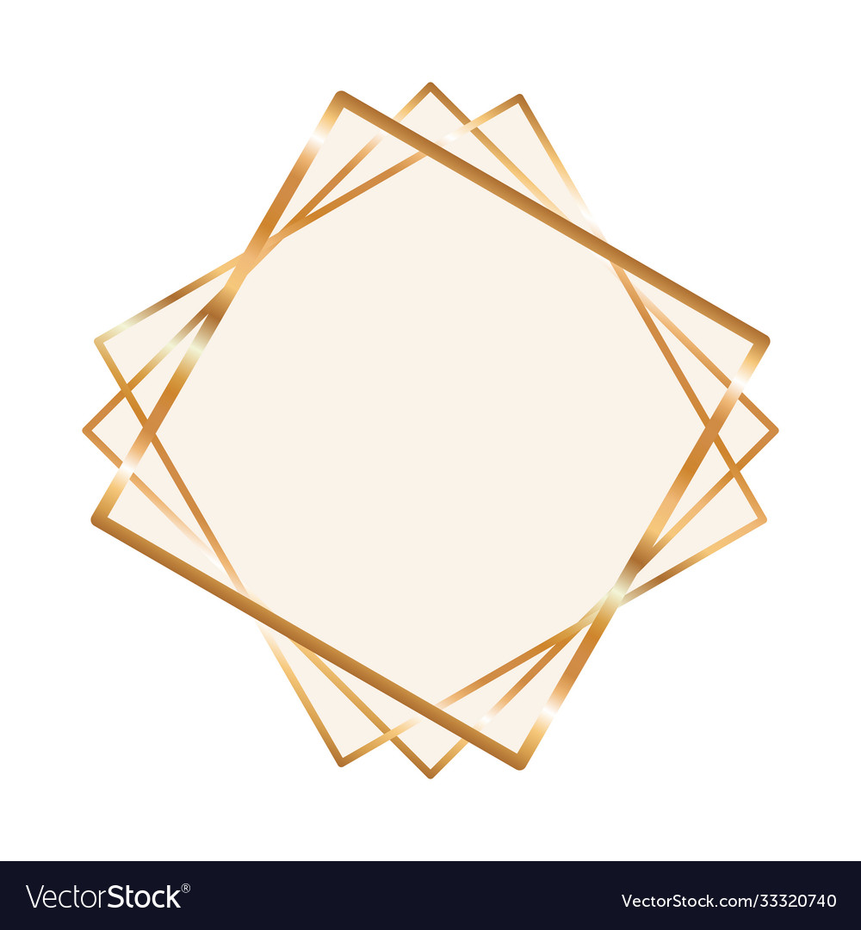

**Happy Birthday**

Dodong



Happy Birthday

Tita Tatang

From: Ging2, Kuya & Vyea





**From: Family**

Daddy Boyet

**Happy 42nd Birthday**





Seneleen

Happiest Birthday,

From: Auntie Lorna



# 

**Happy**

**Mother’s Day**



Happy 13th Birthday

Lola



From: Mama and Julieto

From: Kia



Happy 10th Birthday

Ninia!



Happy Birthday

Kenneth



“A house is made with walls and beams; a home is built with love and dreams.”

Happy 5th Birthday

Ade



From:

Papa, Mama & Lia

@ 40

Nhoy





Papa

&

Mama

Happy

Valentine’s Day